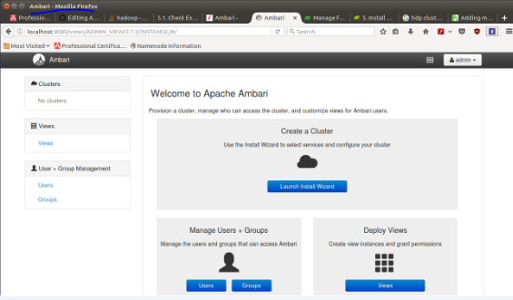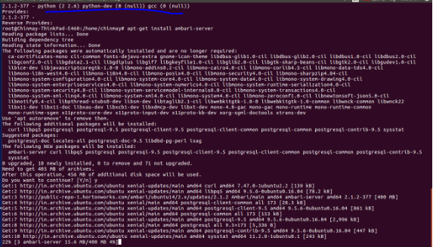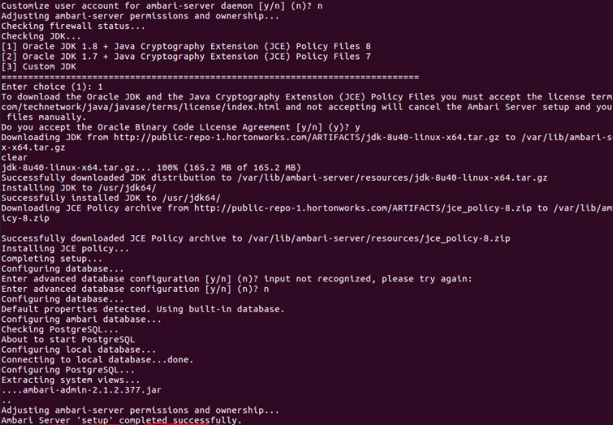

Ambari and its features:

The Apache Ambari project is aimed at making Hadoop management simpler by developing software for provisioning, managing, and monitoring Apache Hadoop clusters.

Ambari provides an intuitive, easy-to-use Hadoop management.

Features:

Provision a Hadoop Cluster:

Ambari provides a step-by-step wizard for installing Hadoop services across any number of hosts.

Ambari handles configuration of Hadoop services for the cluster.

Manage a Hadoop Cluster:

Ambari provides central management for starting, stopping, and reconfiguring Hadoop services across the entire cluster.

Monitor a Hadoop Cluster

Ambari provides a dashboard for monitoring health and status of the Hadoop cluster.

Ambari leverages Ambari metric system for metrics collection.

Ambari leverages Ambari alert framework for system alerting and will notify you when your attention is needed

e.g., a node goes down, remaining disk space is low, etc…

Ambari enables Application Developers and System Integrators to:

Easily integrate Hadoop provisioning, management, and monitoring capabilities to their own applications.